MyJobSearch.us Design Document

Contents

Contact Info 3

Screenshot 3

Notes 3

My Hospitals 4

Screenshot 4

Admin Page 5

Screenshot 5

Notes 5

Feedback 6

Screenshot 7

Notes 7

Feedback: 8

User Admin Page 9

Screenshot 9

Notes 9

Feedback 10

Hospital Details Page 11

Screenshot 11

Notes 11

Admin Management Page 13

Screenshot 13

Notes 13

Password Reset Page 14

Screenshot 14

Notes 14

Recruiter Signup Page 16

Screenshot 16

Notes 16

Map Modify Page 17

Screenshot 17

Notes 17

My Hospitals V2 19

Screenshots 19

Notes 19

My Connections Page 21

Screenshot 21

Notes 21

Overview Page 23

Screenshot 23

Notes 23

My Messages 25

Screenshot 25

Notes 25

Hospital Profile Page 26

Screenshot 26

Notes 27

Rewrite 28

Screenshot 28

Notes 28

Hospital Search Page 29

Screenshot 29

Notes 29

# Contact Info

## Screenshot

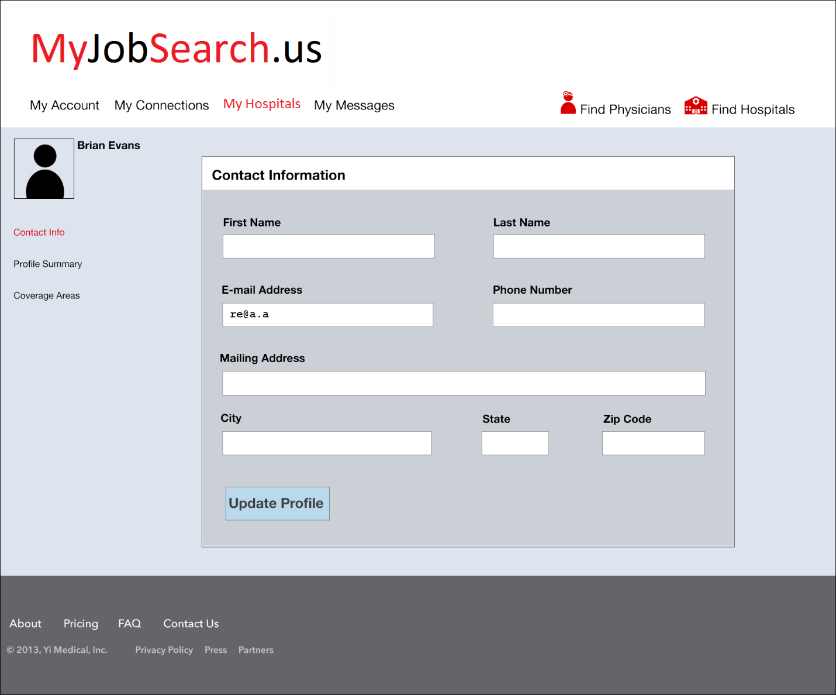

## Notes

* E-mail Address: should not editable and prepopulated with user’s email address from users table.

# My Hospitals

## Screenshot

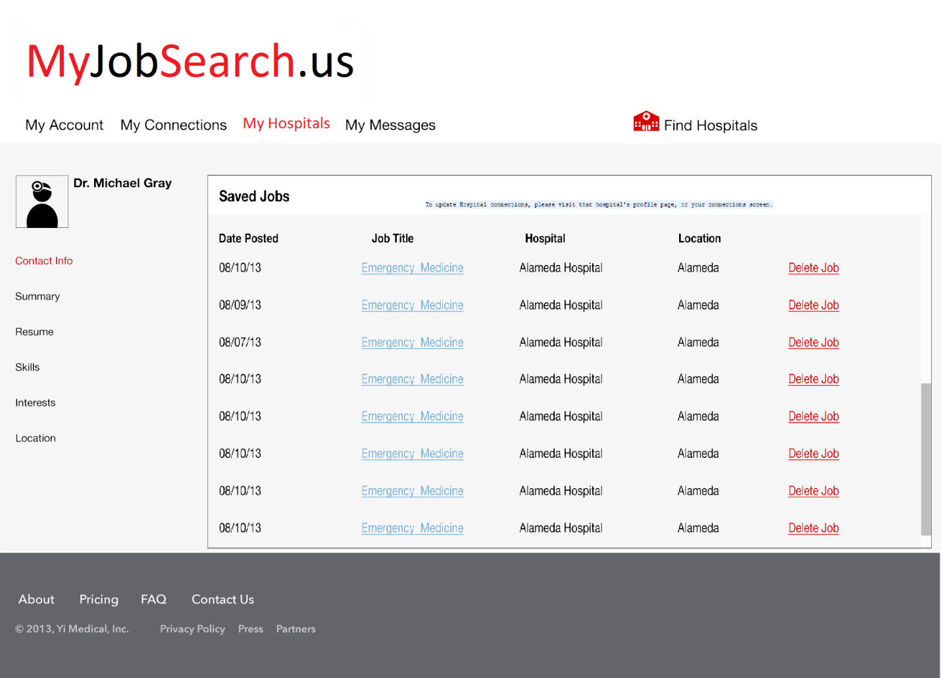

# Admin Page

## Screenshot

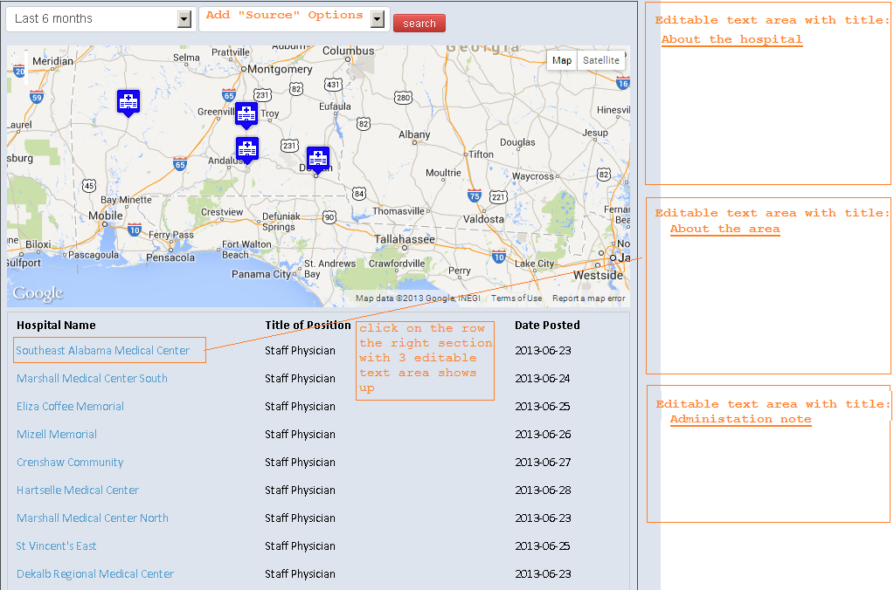

## Notes

* This page is used to show all the hospitals that have jobs or no jobs
  + Search Criteria:
    - Posting time range:
      * No Postings
      * Last day
      * Last week
      * Last Month
      * Last 6 months
    - Source
      * Web Crawler
      * Admin
      * Recruiter
  + Search Result
    - Summary line: hospital name, title of position, date of posting
    - 3 Editable Text Area:
      * About the hospital
      * About the area
      * Administration note

## Feedback

Unhandled Exception

Message:

mysql_real_escape_string() [function.mysql-real-escape-string]: Access denied for user 'root'@'localhost' (using password: NO)

Location:

/localhostapplication/controllers/administrator.php on line 202

Stack Trace:

#0 /localhostlaravel/laravel.php(40): Laravel\Error::native(2, 'mysql_real_esca...', '/home/yikid542/...', 202)

#1 [internal function]: Laravel\{closure}(2, 'mysql_real_esca...', '/home/yikid542/...', 202, Array)

#2 /localhostapplication/controllers/administrator.php(202): mysql_real_escape_string('Southeast Alaba...')

#3 [internal function]: Administrator_Controller->get_createmap()

#4 /localhostlaravel/routing/controller.php(325): call_user_func_array(Array, Array)

#5 /localhostlaravel/routing/controller.php(285): Laravel\Routing\Controller->response('createmap', Array)

#6 /localhostlaravel/routing/controller.php(165): Laravel\Routing\Controller->execute('createmap', Array)

#7 /localhostlaravel/routing/route.php(153): Laravel\Routing\Controller::call('administrator@c...', Array)

#8 /localhostlaravel/routing/route.php(124): Laravel\Routing\Route->response()

#9 /localhostlaravel/laravel.php(165): Laravel\Routing\Route->call()

#10 /localhostpublic/index.php(34): require('/home/yikid542/...')

#11 {main}User Data Page

## Screenshot

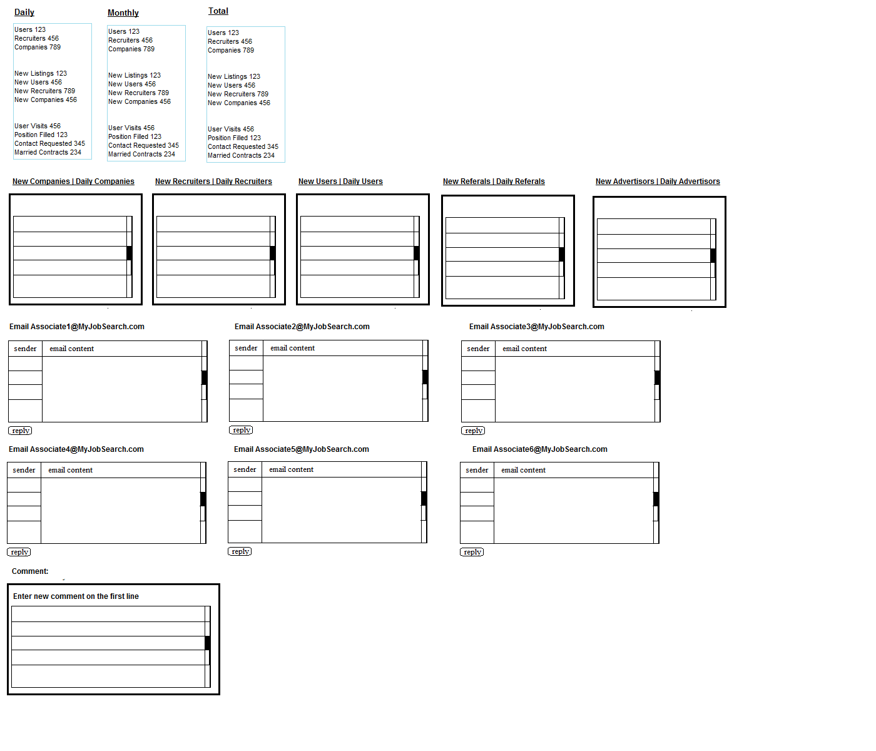

## Notes

1. This is for user data analysis page. This page will show everything in one page, seems silly, but this is what the user wants, might load slow, but they want to show everything in one page.
2. Needs an auto refresh function on this page, every 5 minutes
3. You can rearrange the sections to make it more readable
4. The database part is not ready, so please mock up all the data in the controller
5. Two editable areas:
   1. Email section, when you click on reply, a pop up will show up so the user types in the message
   2. Comment Section will list all the comments, user can type in on the first line for new comment
6. Data Mock up
   1. 3 objects dailyData, monthlyData, totalData, they all have 10 fields which holds numbers: userNumber,recruiterNumber,companyNumber,newListingNumber, newUserNumber,newRecruiterNumber,newCompanyNumber,userVisitNumber,positionFilledNumber,contractRequestedNumber,marriedContractNumber
   2. 10 lists: newCompanyList, dailyCompanyList, newRecruiterList, dailyRecruiterList, newUserList, dailyUserList, newReferalList, dailyReferalList, newAdvertisorList, dailyAdvertisorList, each list holds a list of objects, which has two fields, one is name, one is id, name is used to show on the list, and id is used to put on the url of the name, so the user can click on it.
   3. 6 lists of emails: each list composes of emailObject, which holds two fields, one senderName, one email id which is used for user to click on the sender, brings up the content of email
   4. A list of comments: each comment will have two fields: comment itself and timestamp.
7. But the database is not available right now, so in the controller, instead of doing

$View-> dailyData = DB::Query($sql)

You create a mock object or arrays

$View->dailyData = array (“userNumber”->123, “recruiterNumber”->456…);

For list:

$View->newCompanyList = array(1->”companyABC”, 2->”companyDEF”…);

In the view code, then you can use dailyData and newCompanyList as if it is coming from the database.

## Feedback:

1. See note3, please redesign the layout of this page make it more concise more readable, right now it is expanding too long, maybe have the top number part horizontally displayed?
2. See note5a, reply button doesn’t work
3. Are all these block areas scrollable? Can you make the mock up data bigger, so I can at least see a scrollbar like in the screenshot
4. See note6c, when you click on the sender, the email content should show on the content panel, this is not implemented. Please highlight the clicked sender.
5. See note6b, the names should be clickable, this is not implemented.

# User Admin Page

## Screenshot

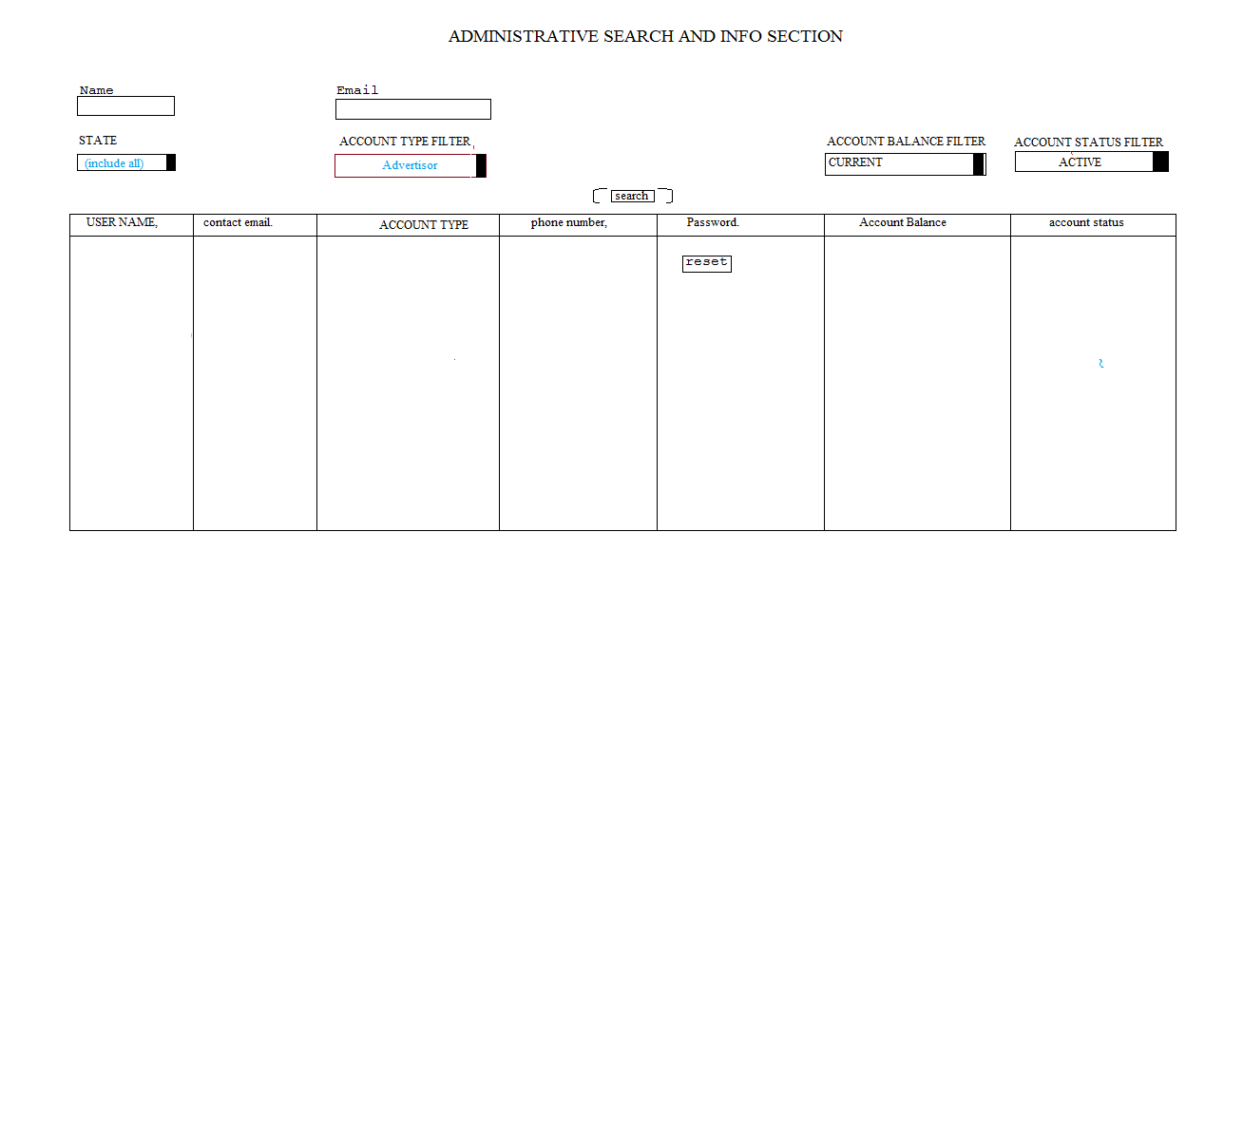

## Notes

1. The search form includes:
   1. Textbox: Name
   2. Textbox: Email
   3. Dropdown: State (list of all US states)
   4. Dropdown: Account type
   5. Dropdown: Account balance
   6. Dropdown: Account status
2. Data mock up:
   1. For the 3 dropdowns, the values will be hard coded on the screen, for right now, just mock up the options, we can fill in the value later, for example:

<select name=*"ACCOUNT TYPE FILTER"* id=*"accntType"*>

<option>None</option>

<option value=*"filter1"*>TYPE 1</option>

<option value=*"filter2"*>TYPE 1</option>

<option value=*"filter3"*>TYPE 3</option>

</select>

* 1. For the search result, mock up the data in the controller, it’s a list of result objects, which contains 6 fields: userName, userEmail, accntType, phoneNumber, accntBalance,accntStatus.
  2. The password column will just have a reset button, for the admin to reset the password and send the email, you don’t need to implement the actual function for right now, just put a place holder and link there.

## Feedback

1. Do not put style separately in css.css file, put the styles directly in the view file, it’s easier for us to integrate, even if the style is duplicated in several pages, that is ok. Please clean up and remove css.css the file completely.

The file still exists, and can be searched in these files:

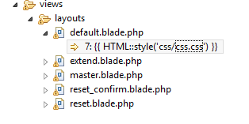

1. Make the search form more concise, right now it is already taking half of the screen, the user would have to scroll a lot to see the result.

This is not changed.

1. Can you make some mock up data that always return something when I click on search, right now I can’t see the search result.

# Hospital Details Page

## Screenshot

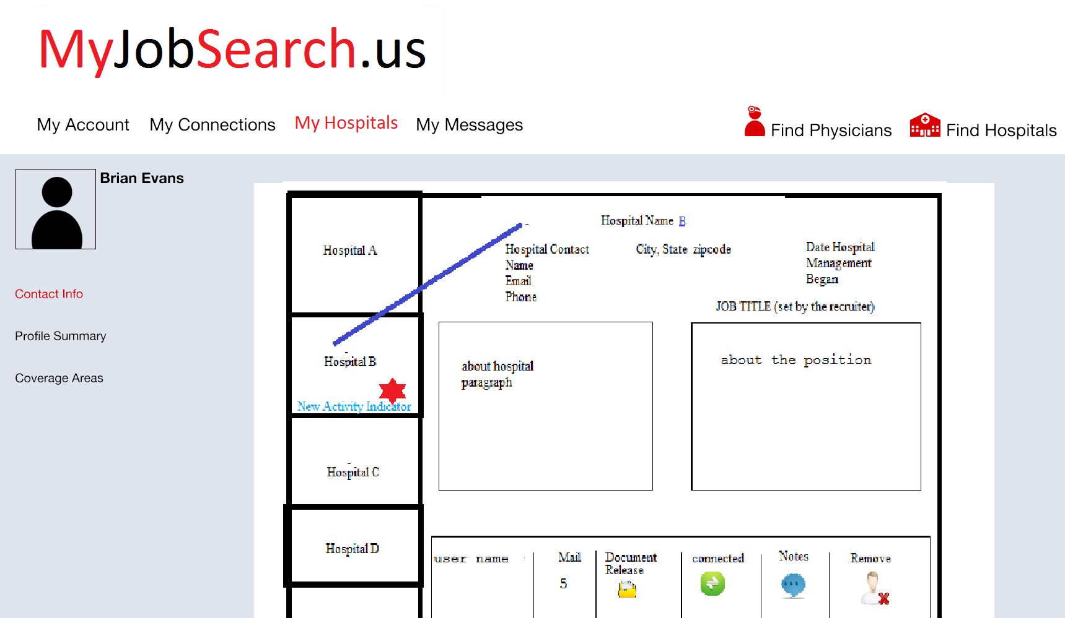

## Notes

1. The layout is the same as “contact info” page, although the footer is not shown in the screenshot, it should show on the page
2. Icons are not shown complete on this page, please find a set of nice icons to use.
3. The main page includes:
   1. Left side: a list of hospital names, with indicator when there is something new happening on the hospital
   2. Right side: when the hospital name is clicked, the center part will show the detail of the hospital, includes:
      1. Top Section: Hospital Information
      2. Center Section: 2 editable text area: about the hospital and about the job. Job title is an editable text field
      3. Bottom section, a list of user information
         1. Name
         2. Mail: number of new emails
         3. Document release: when the document is released, show document open icon, otherwise show request document icon.
         4. Connected: if connected, show green connection icon, otherwise show request connection icon
         5. Notes: if there is note, show the note icon, hover show the note popup
         6. Remove: remove the user from the connection.
4. Data Structure:
   1. A list of Hospital on the right, each hospital includes name and id, name is used to show on the screen and id is user to click on to show the details
   2. Detail include a hospital object, which includes: id, name, contactName,contactEmail, contactPhone, city, state, zip, startDateOfManagement, jobTitile, aboutHosp, aboutJob
   3. The hospital is also related to a list of users, which includes: userName, countOfNewMsgs, isDocumentReleased,isUserConnected,notes

# Admin Management Page

## Screenshot

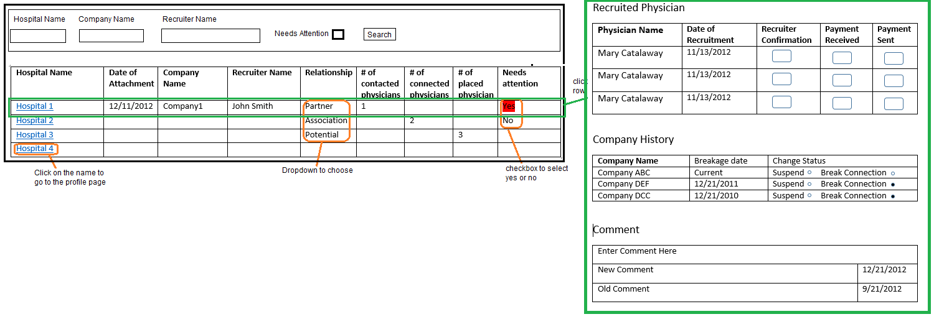

## Notes

1. This page includes the search form and search result.
2. Search form includes:
   1. Hospital name: text field
   2. Company name: text field
   3. Recruiter name: text field
   4. Needs attention: checkbox
3. Search results includes summary of list of hospitals and click on the row shows the detail on the right side
4. The summary table includes: hospital name, date of attachment, company name, recruiter name, relationship, # of contacted physicians, # of connected physicians, # of placed physician, Needs attention.
5. These columns needs to be editable:
   1. Relationship: click on the column shows the dropdown to pick from a list of (partner, association, potential)
   2. Needs attention: the column shows a checkbox, the user can check or uncheck, don’t use the drop down as shown on the screenshot.
6. Click on hospital name goes to hospital profile page
7. Click on the row go to the detail page
8. Detail page includes three sections:
   1. Recruited Physician, includes a list of Physician name, date of recruitment, 3 editable checkboxes items: Recruiter confirmation, Payment Received, Payment Sent
   2. Company history, includes a list of company name, date of breakage (if it’s active, show “current”), and editable column “change status”, which user can choose from one of two radio buttons: “suspend” or “break connection”
   3. Comments: first line to enter new comment and then listed the comments in reverse timestamp.

# Password Reset Page

## Screenshot

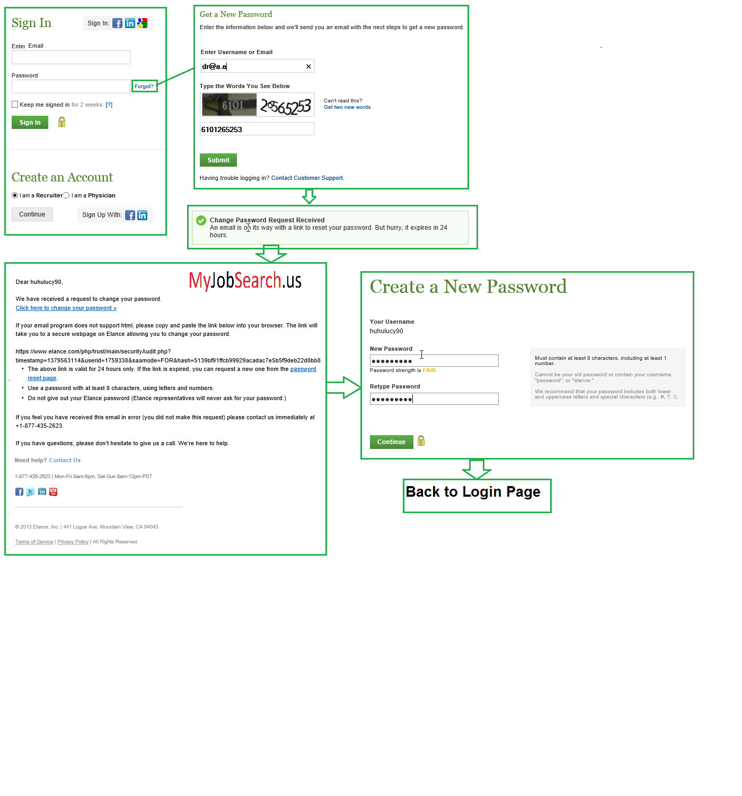

## Notes

1. Basically this work flow is a copycat of elance, including these pages:
   1. Sign in page
   2. Password Reset Request page
   3. Reset Verification Page
   4. Email
   5. Password Reset Page

# Recruiter Signup Page

## Screenshot

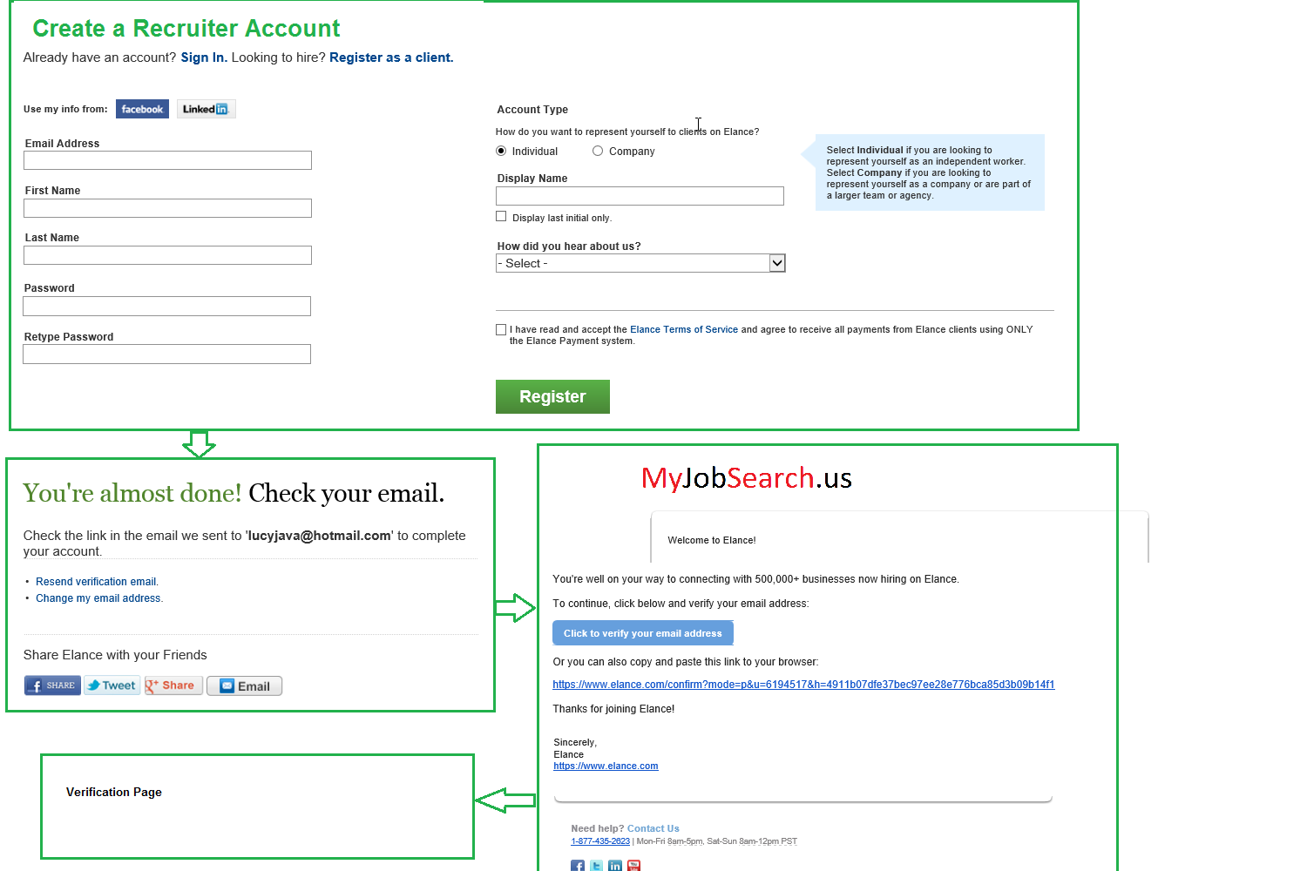

## Notes

Basically this work flow is a copycat of elance, the flow includes these pages:

1. Create an account page
2. Almost done page
3. Email
4. Verification Page when click on the link in email.

# Map Modify Page

## Screenshot

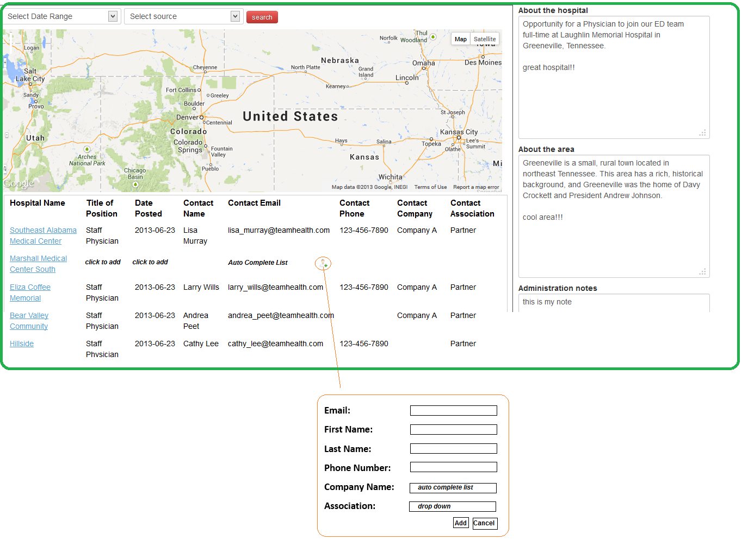

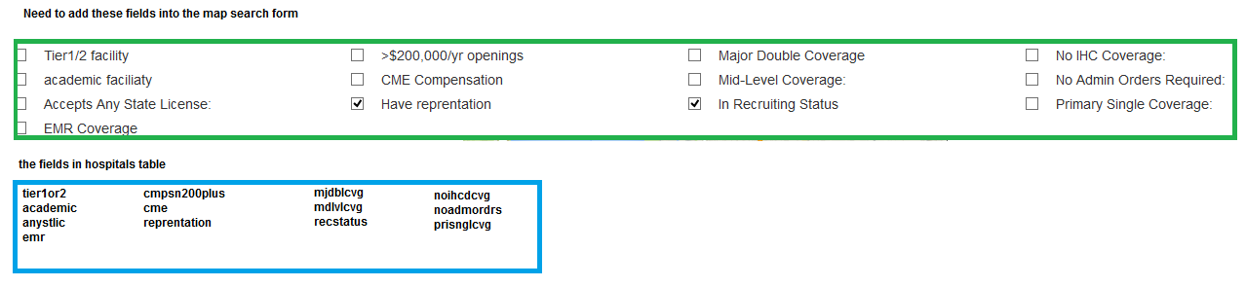

## Notes

1. This page is the modification of Admin Page
2. The information is related to three tables: hospitals, jobs_edw, recruiter (see recruiter.sql to add table)
3. The zoom control is hard to see
4. Map:
   1. The zoom control is hard to see right now, needs to be fixed.
   2. The search result list should only be what is in the range of the map area on the screen, if you drag or zoom the map, the list under it will be changed accordingly.
   3. When you click on the tag on the map, the corresponding row on the list should be highlighted.
5. The result list includes more fields now: Hospital Name, Title, Date Posted, Contact Name, Contact Email, Contact Phone, Contact Company, Contact Association. The highlighted blue fields are information from jobs_edw and the yellow fields are from recruiters table.
   1. Jobs_edw.hospid = hospitals.id
   2. Jobs_edw.contact_email=users.email
   3. Recuiter.id=users.id
6. When date range is “No Posting”, the rows from hospitals that don’t have a row in jobs_edw will be returned, only hospital name will show, the other fields need to be entered by user:
   1. Title: click to add
   2. Date Posted: click to popup a calendar to pick, in MM/DD/YYYY format
   3. Contact Email: auto complete list. This list is the unique contact emails in jobs_edw table
      1. If the user picks an email from the list, the other fields will be populated based on that email
      2. If no email exists, the user will click on the add icon and a pop up to enter the other fields, the information of this pop up will be inserted into these tables:
         1. Email: **users**:email
         2. Firstname, lastname,phonenumber:users_**metadata**
         3. Contact name, association: **recruiter**
   4. All the other information: title, date posted, about hospital, about area will be inserted into jobs_edw table
7. Data clean up task: needs to extract existing data from jobs_edw table and inserted into recruiters and users tables.
   1. Contact email: goes to user email
   2. Contact name: goes to usermetadata
   3. Source: goes to recruiter company: teamhealth or emp
   4. Association on recruiter will be default to potential
8. We need to add extra filters onto the search form, see screenshot2.

# My Hospitals V2

## Screenshots

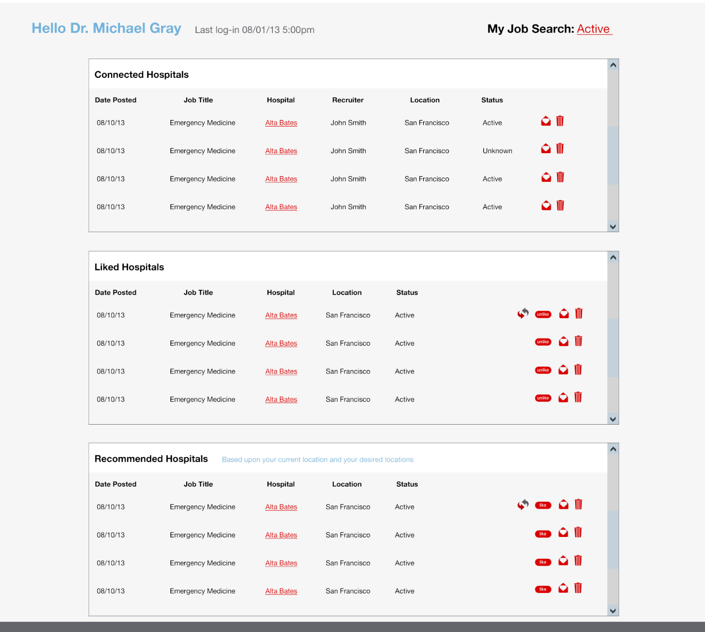

## Notes

1. This page is the most mature page we have,
   1. Static page design is done /views/hospital/hospitals.blade.php, there is a layout template added /views/layouts/physician_master.blade.php, PLEASE DO NOT CHANGE THE LAYOUT FILE.
   2. Controller: hospital.php::get_hospitals, we already put some queries there, you need to test it to make sure they are working. Then integrate the result to dynamic view. Remember to import phase4.sql file for new tables and procedures.
2. Actions on the page, need to be implemented
   1. Connection: add/remove rows from connection, you could figure out the relationship based on the data retrieve query.
   2. Like/unlike: add/remove rows from connection, you could figure out the relationship based on the data retrieve query.
   3. Messages: Don’t’ worry about this one for right now
   4. Trash: Hide this hospital from the result of all these 3 list. (this is a bit tricky)

# My Connections Page

## Screenshot

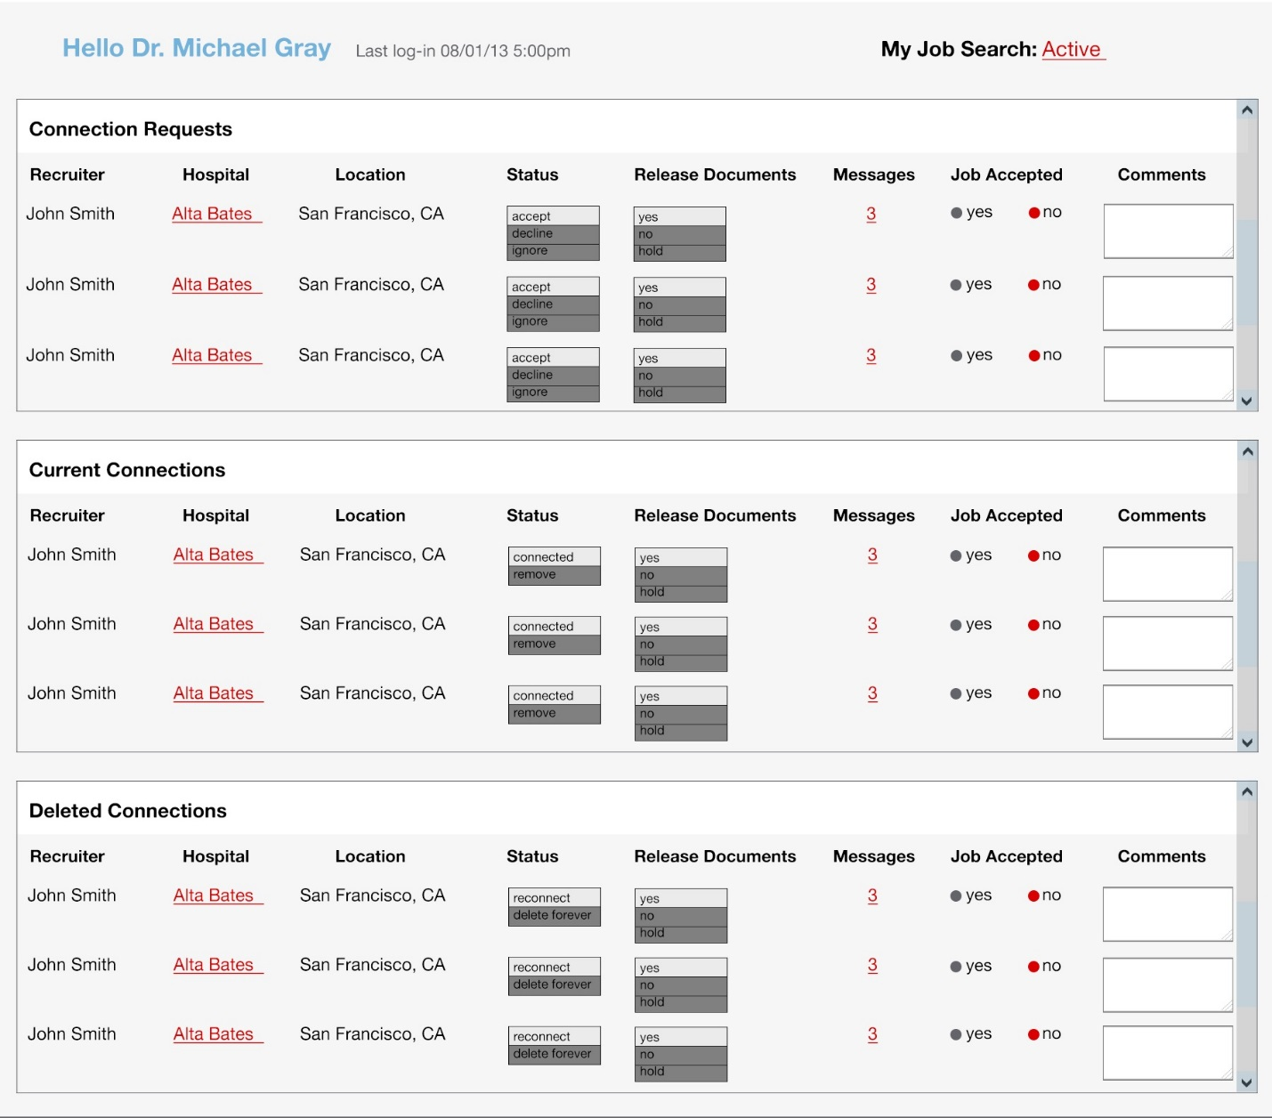

## Notes

1. This page has only design picture, needs controller and view page. There are database changes, please import the latest testdb.sql
2. Please use /views/layouts/physician_master.blade.php as the template (the same header and footer). For the page itself, follow the same style as /views/hospital/hospitals.blade.php.
3. This page includes 3 lists, they are the query results of the following tables:
   1. Connections, recruiter, hospitals, doc_perms
      1. Connections.follower = recruiter.id
      2. Connections.reference = hospitals.id
      3. Doc_perms.visitor_id = recruiter.id
      4. Doc_perms.hosp_id = hospitals.id
   2. Drop downs are for actions defined in miscdata.php.get_connaction

**switch** ($action) {

**case** "AA":

$Perms->comm_status = 2;

$Response['action'] = "connect";

$Response['response'] = "Connection made";

**break**;

**case** "AI":

$Perms->comm_status = 0;

$Response['action'] = "connect";

$Response['response'] = "Connection ignored";

**break**;

**case** "AD":

$Perms->comm_status = -99999;

$Response['action'] = "connect";

$Response['response'] = "Connection Dropped";

**break**;

**case** "DY":

$Perms->doc_release = 1;

$Response['action'] = "documents";

$Response['response'] = "Documents Released";

**break**;

**case** "DN":

$Perms->doc_release = 0;

$Response['action'] = "documents";

$Response['response'] = "Documents Withheld";

**break**;

}

* 1. The three lists are based on the comm_status,
     1. 0: Connection requests
     2. 2: Current Connections
     3. -99999:Deleted Connections

1. Please load the data in ajax manner, each list will be a separate ajax call
2. Messages and Job Accepted columns: requirement coming soon.

# Overview Page

## Screenshot

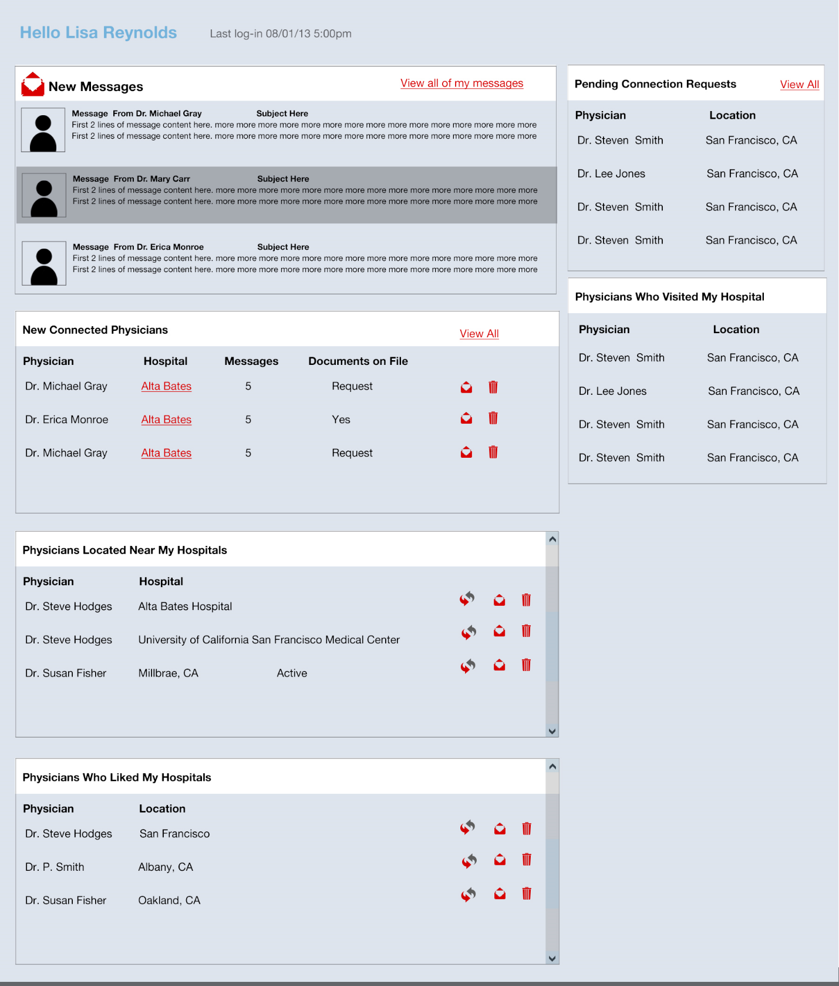

## Notes

1. This page is another mature page we have,
   1. Static page design is done /views/home/overview.blade.php. Please do not change style and layout template
   2. Controller: home.php::get_overview, we already put some queries there, you need to test it to make sure they are working.
2. There are 6 lists in this page, the queries are in the method get_overview_old, but it needs to be written, so all the lists are done in ajax way to speed up page loading. Feel free to change the query and procedures to optimize it.
   1. New messages: $messages
   2. New connected: connectedDocs
   3. Located near my hospitals: docsByHome
   4. Liked my hospitals: docsByFaved
   5. Requested connection: please write query for this, this is the query to find out the person who requested connection to me.
   6. Visited my hospitals: docsByVisited
3. The actions on this page are:
   1. Connect: connect the physician with me, it’s similar to the my connections page
   2. Message: TBD
   3. Trash: TBD
4. Please create some data in the database so there are at least 4 rows in all the lists.
5. New sql file: messages.sql

# My Messages

## Screenshot

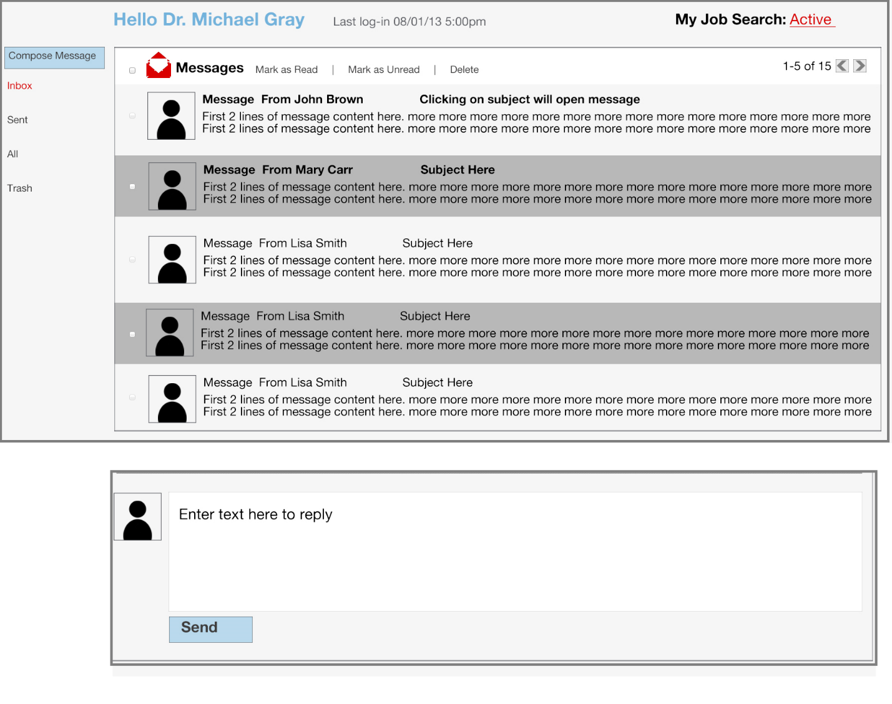

## Notes

1. This page is the expansion of the messages part on the overview page, to show all the messages, needs pagination, show 5 on each page.
2. Please use /views/layouts/physician_master.blade.php as the template (the same header and footer).
3. The extra stuffs are: side menu and actions.
4. Actions include:
   1. Click on the subject, will expand the whole content of the message and a reply text area right below the message, so the user can reply message
   2. Mark as read: “All” messages contain read and unread.
   3. Mark as unread: “Inbox” will only contain new (unread) messages
   4. Delete
5. The database table is message, you might need to add more columns for the actions.

# Hospital Profile Page

## Screenshot

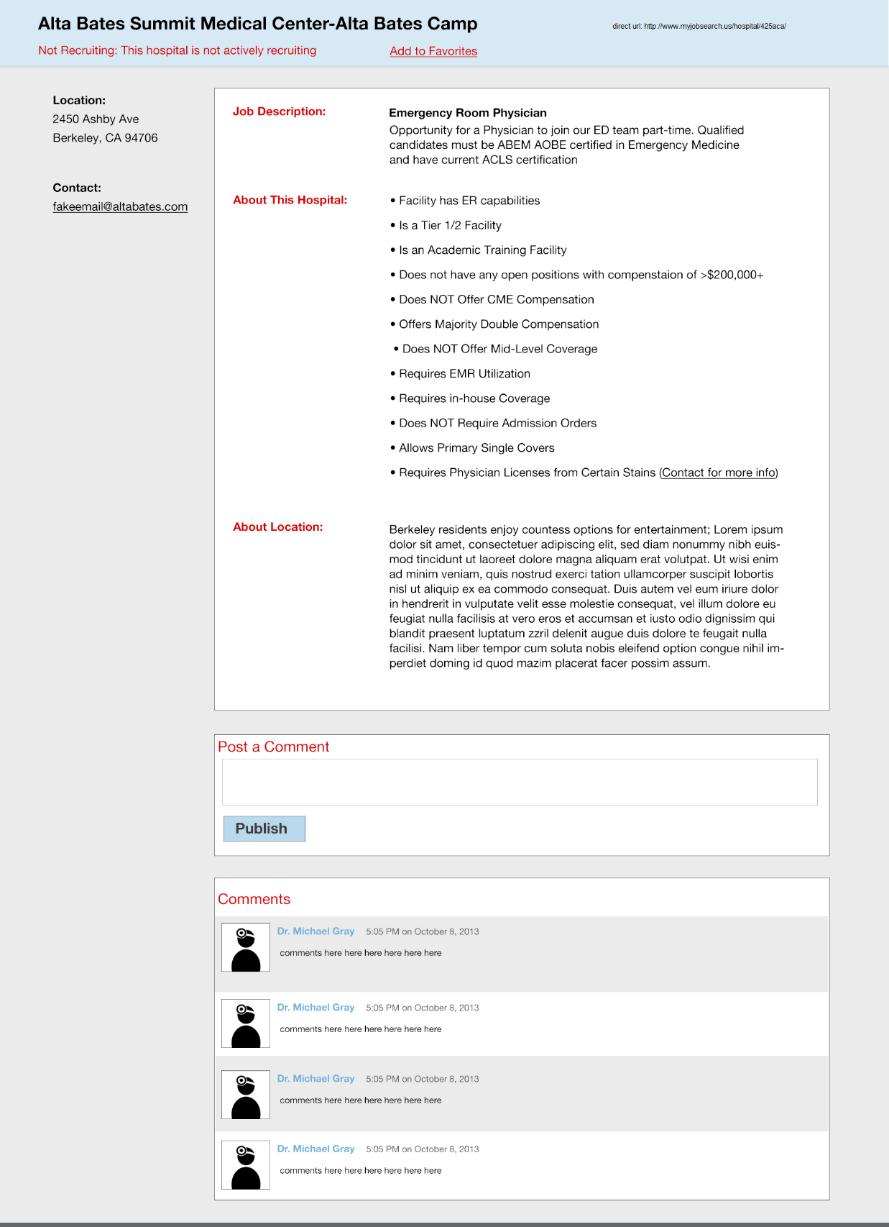

## Notes

1. This page needs controller and view page, Please use /views/layouts/physician_master.blade.php as the template (the same header and footer).
2. Please try to use bootstrap style as much as possible instead of creating your own style
3. Data reading are from the join of jobs_edw and hospitals table, I put some queries on the method hospital.php get_profile method, needs to be tested and probably add more.
   1. Actively recruiting: check if jobs_edw has a row for the hospital
   2. Location: hospital
   3. Contact: jobs_edw
   4. Job description: jobs_edw, cpara
   5. About this hospital: table hospitals, check the values of all the filter criteria to show the line, see the Map page for reference
   6. About location: jobs_edw lpara
   7. Comments: see the query in the method.
4. Actions:
   1. Add to favorites:

See the $connection variable in the method, if it is not 0, set the value as Favorited. Otherwise shows as “Add to favorites”, click on it insert into the connection table.

* 1. Post a comment:

DB::table('hospcomments')->insert(array(

'author' => Sentry::user()->get('id'),

'recipient' => Input::get('recipient'),

'message' => Input::get('message'),

'created_at' => date('Y-m-d H:i:s'),

'updated_at' => date('Y-m-d H:i:s')

));

# Rewrite

## Screenshot

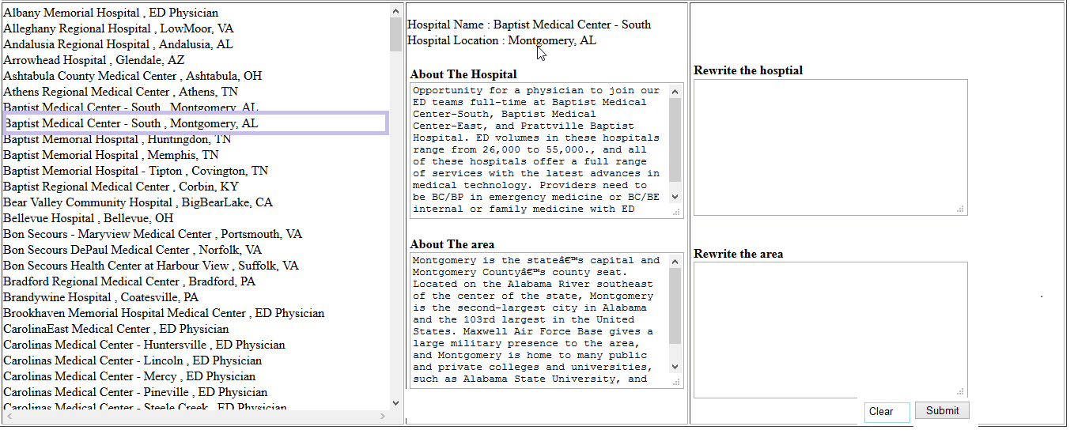

## Notes

1. This page include 3 columns
   1. Left column is the list of the hospital names:
   2. When a hospital is clicked, the center column will have two text areas that are read only, scrollable.
   3. Right column includes two editable textarea. After the editing is finished, user click on submit button to submit the change, click on “Clear” button to clear the editing.
2. The data is getting from jobs_edw table, please see jobs_edw.sql
   1. Left list is “SELECT `HName` , `Location` , JobID FROM `jobs_edw` WHERE HName!='' and Attached_at is null ORDER BY `jobs_edw`.`HName` ASC”
   2. The center column is cpara and lpara by jobid
   3. The right column is cpara_clean and lpara_clean by jobid
3. The html file is ready, file is at /view/hospital/hospitalprofile.blade.php, route is added at. http://localhost/hospitalprofile/abc, please don’t change layout template and style in the file.

# Hospital Search Page

## Screenshot

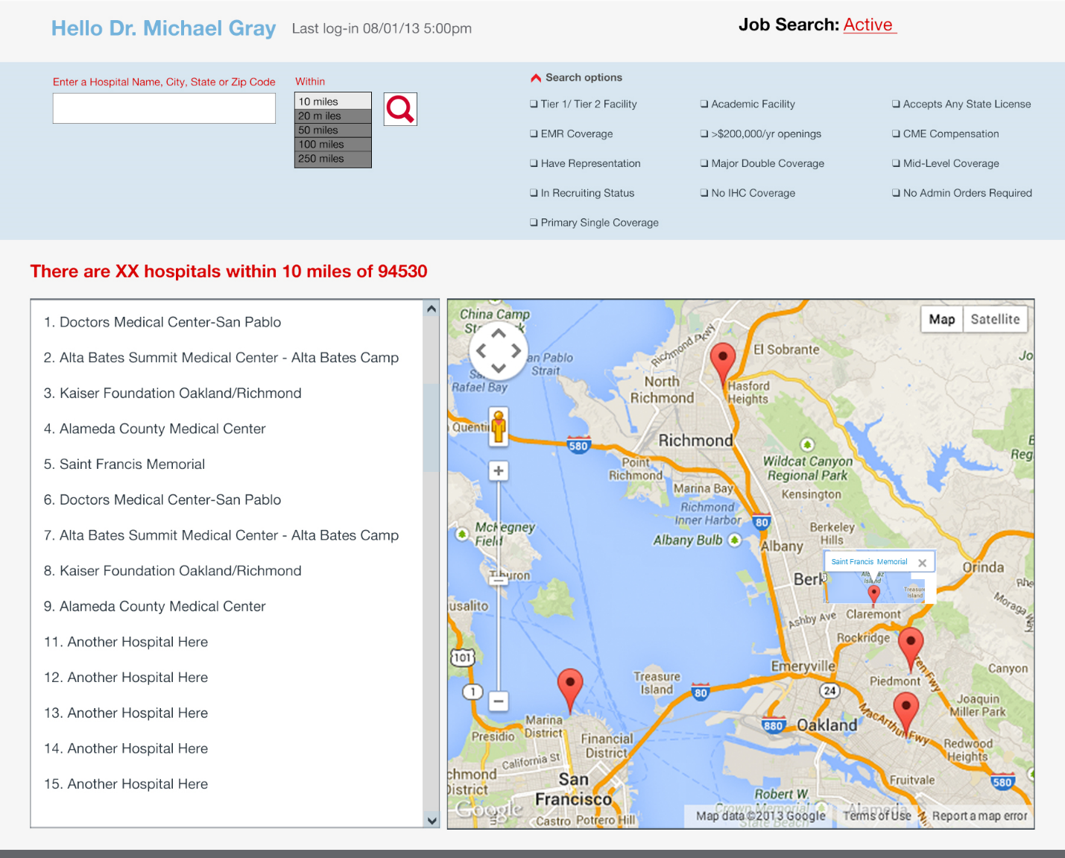

## Notes

1. The html file is ready, file is at /view/hospital/search_v2.blade.php, route is added at. <http://localhost/hospitalsearch>, please don’t change layout template and style in the file.
2. The old implementation is added too, please use/fix the implementation and put the logic in the new file search_v2.blade.php.
   1. Two methods in the hospital.php: get_search_old and post_search_old
   2. Two old pages: search.blade.php and results.blade.php